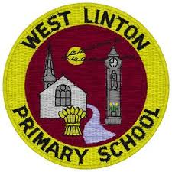

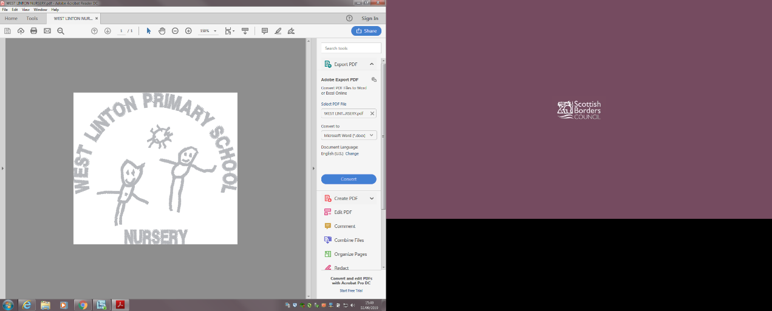

Learning Together To Achieve Our Best

**Curriculum Rationale**

Kindness, Honesty and Respect

**Our Main Drivers for the Curriculum**

* Emotional Health & Wellbeing; Building Resilience and developing a Growth Mindset
* High attainment in Literacy and Numeracy
* Skills based learning across the curriculum
* Progressive, challenging and supported learning
* Community Involvement
* Outdoor Learning
* Pupil Leadership

**What makes us unique?**

* Rural community with access to rich, natural environments as well as Scotland’s capital city
* Our pupils have a wide range of achievements
* Our Scottish Borders Traditions – Whipman
* Staff enthusiasm and expertise, providing pupils with a variety of experiences
* School building and grounds
* High aspirations and standards

**We are all learners who use**

**Learning Powers**

* Concentrate
* Don’t Give up
* Be curious
* Have a go
* Use your imagination
* Be co-operative
* Keep improving
* Enjoy Learning

At West Linton Primary our curriculum develops pupils’ understanding of the United Nations Convention of the Rights of the Child (UNCRC) through our Assemblies and Citizenship Gatherings; through our Class Charters and in our everyday interactions.

As a school community we are committed to inclusion and getting it right for every child, to high quality learning & teaching, to an open door policy and to a friendly, welcoming ethos which encourages professional love.

At West Linton Primary our learners are exposed to a Broad General Education through discrete teaching in Mathematics and Literacy and by using Curricular Bundles to connect and transfer their learning into motivating interdisciplinary contexts.